**Structural Imaging LLC** Radar Scanning Services and Roadway Profilograph

**Structural Imaging LLC** Radar Scanning Services and Laser Profilograph

**Why Structural Imaging LCC?**

* Experienced
* Free Estimates
* Advanced Technology
* Flexible scheduling
* Large coverage area

**The Next Step**

**Now that you know what we do and how it’s done, what it the next step? Please feel free to contact our owner, Sean Golembiewski for questions, concerns, and quotes for your next project.**

**E-mail: Seang@swankco.com**

**Phone: 724-415-6189**

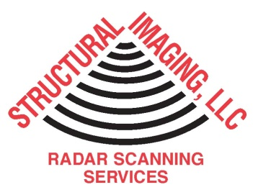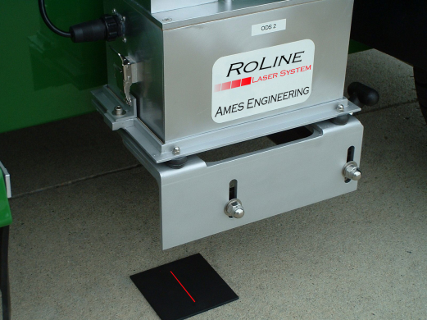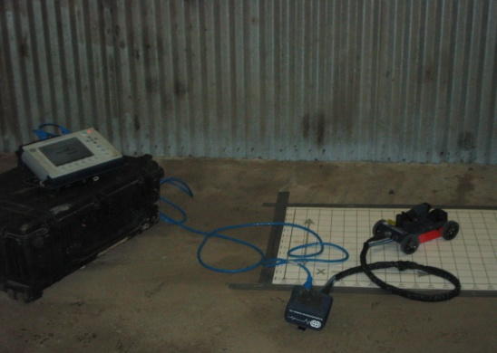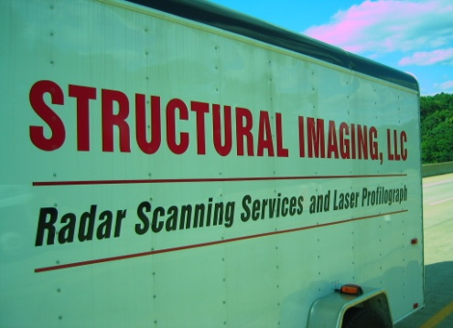

WWW.STRUCTURALIMG.COM

**Our company is located in Apollo, PA in the outskirts of Pittsburgh, Pennsylvania. Since 2008REQUEST A QUOTEsINCE 2008, Structural Imaging LLC has been growing to meet the many challenges that have confronted the commercial construction industry by utilizing radar scanning of concrete walls and floors. This allows the contractor/owner to know what they are getting into before the project even starts. We also have a location in Virginia Beach, VA to serve the mid Atlantic region.**

Sean Golembiewski

Phone: 724-415-6189

seang@swankco.com

200 Sierra Dr.

Apollo, PA 15613

Phone: 724-415-6189

seang@swankco.com

WWW.STRUCTURALIMG.COM

**Structural Imaging LLC: Radar Scanning Services**

**Roadway Laser Profilograph**

**Our Machines and Tools**

**Radar Scanning**

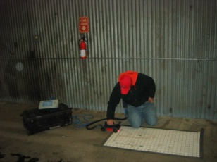

**The lasers attached to our machine allow us to profile the existing or new roadway with “Hands Free” approach. This profile shows the vertical aspect of the road, including crest and sag curves, and the straight grade lines connecting them. Using state of the art technology, we can provide you with a digital profile determining the consistency of the roadway. We are certified in Pennsylvania, Ohio, West Virginia, and other states are available upon request.**

**Ground Penetrating Radar (GPR) is a method that uses radar pulses to image the subsurface underneath the device. GPR can evaluate base and sub-base layers with data collection densities not obtainable by traditional labor-intensive methods, such as core drilling. It can detect objects, cracks and voids, and changes in material.**

**Our handheld radar machine allows us to scan in compact places and have very accurate results. Using the grid system we have consistent results that will satisfy you and your company.**

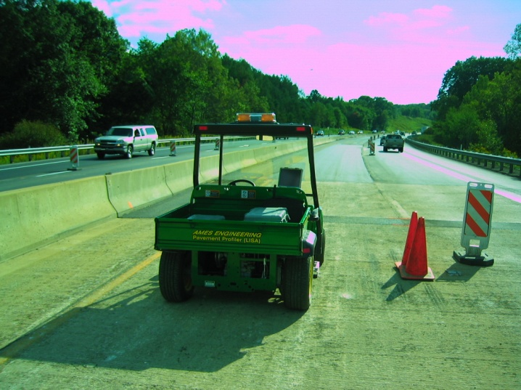

**Uses and Benefits of Roadway Profiling**

**Benefits of Structural Imaging**

* **Up to 18” Depth Radar Capacity**
* **Locating safe areas to drill**
* **No radiation hazard compared to the (X-Ray) alternative**
* **Determining rebar size and spacing**
* **Identifying hydronic lines**
* **Identifying air/water filled voids**
* **Beam and Grade beam locating**
* **Saves time using efficient method**
* **Reduced associated costs with other methods**
* **Many new Penndot roadways require PA Test Method No. 428**
* **Design guidelines take into account** [**speed**](http://en.wikipedia.org/wiki/Speed)**, vehicle type,** [**road grade**](http://en.wikipedia.org/wiki/Grade_(slope)) **(slope), view obstructions, and** [**stopping distance**](http://en.wikipedia.org/wiki/Stopping_distance)**.**
* **Ensure smooth roadway surface for many years to come**
* **Efficient way to lay out job stationing**

**Our current lasers are attached to a utility vehicle that can travel approximately 15mph.This allows for little disruption to traffic patterns and minimal time on the job to ensure the smallest costs and best product to our customers.**